Year 1 Homework Menu – Summer 1
Maths  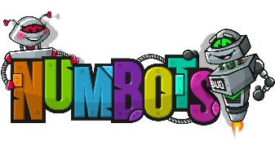  Log on to ‘Numbots’ to build up your fluency and understanding with addition and subtraction. | Phonics  Practice your daily speed sounds lessons using your QR codes handed out every Friday.  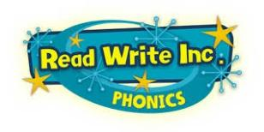 | Reading    Please make sure you are reading every day and get your reading diaries signed to earn your bronze, silver and gold badges.
Art  We are learning about the artist James Rizzi, who uses bright colours, bold outlines, and happy, cartoon‑style buildings and faces.  Can you make a picture of yourself in the style of James Rizzi? Draw yourself with big eyes, bright colours, and a happy face. | Science  In science we are learning about plant parts.  Can you make a collage of a plant and label all the different parts? | History  Can you find out 5 facts about the Victorian Era? How did Victorian schools differ from your school day?  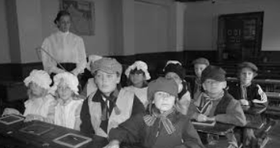
Choose at least one of the following activities to complete during this half term. Please hand in your completed work by Friday 16th May.
Remember you get 10 house points for your team for every piece completed. Please put in your best effort and be prepared to share your work with the class.



