Reception Writing Curriculum

 | Autumn Term  1 | Autumn Term  2 | Spring Term  1 | Spring Term  2 | Summer Term  1 | Summer Term  2
Drawing Club |   The Tiger Who Came to Tea  By Judith Kerr  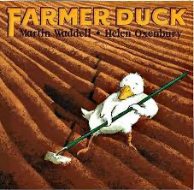  Farmer Duck  By Martin Waddell | 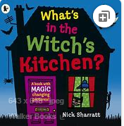  What’s in the Witch’s Kitchen by  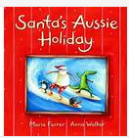  Santa’s Aussie Holiday by Maria Farrer and Anna Walker | 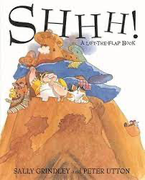  Shhh! By Sally Grindley  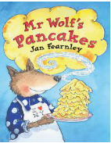  Mr Wolf’s Pancakes by Jan Fearnley | 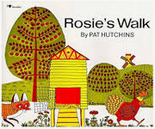  Rosie’s Walk by Pat Hutchins  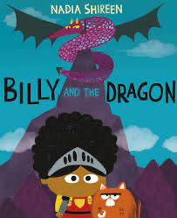  Billy and the Dragon by Nadia Shireen |   Not Now Bernard by David McKee  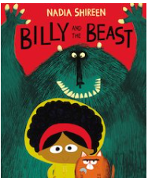  Billy and the Beast by Nadia Shireen |   Billy’s Bucket  By Kes Gray  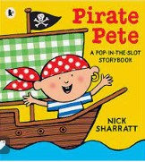  Pirate Pete by Nick Sharratt

