Year 2 – 2024 – 2025
Autumn 1 | Spring 1 | Summer 1
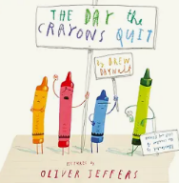  The Day the Crayons Quit by Drew Darwell  (17 days)  Text Type: Non-fiction  Genre: Persuasive Letter  Topic: School Life/School’s Out  Cross curricular links: Drama  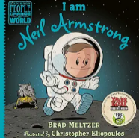  Neil Armstrong by Brad Meltzer  (17 days)  Text Type: Non-fiction  Genre: Recount  Topic: Significant People  Cross curricular links: History | 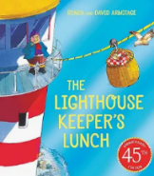  The Lighthouse Keeper’s Lunch by Ronda Armitage  (15 days)  Text Type: Narrative  Genre: Story  Topic: Healthy Eating  Cross curricular links: Design and Tech  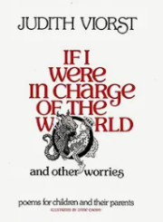  If I Were in Charge of the World by Judith Viorst  (14 days)  Text Type: Poetry  Genre: Free Verse  Topic: Be the change  Cross curricular links: PSHE | 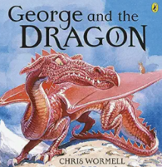  George and the Dragon by Christopher Wormell  (18 days)  Text type: Narrative  Genre: Adventure  Topic: Legends / British Values  Cross curricular links: Citizenship  Big Cats  (18 days)  Text type: Non-fiction  Genre: Non-Chronological Report  Topic: ROAR!/Africa  Cross curricular links: Geography/Science
Autumn 2 | Spring 2 | Summer 2
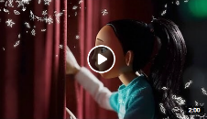  My Christmas Star by The BBC  (18 days)  Text Type: Narrative  Genre: Story  Topic: Christmas/Follow The Star  Cross curricular links: PSHE  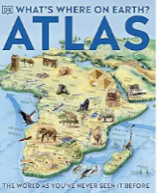  Habitats Based on the book, What’s Where on Earth Atlas’ by Dorling Kindersley Limited  (14 days)  Text Type: Non-fiction  Genre: Non-chronological  Topic: Our World  Cross curricular links: Geography/Science | 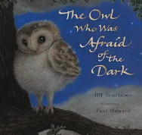  The Owl Who Was Afraid of the Dark by Frank Jill Tomlinson  (16 days)  Text Type: Narrative  Genre: Adventure  Topic: Light & Dark/Illuminate  Cross curricular links: Science  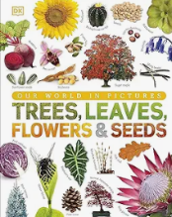  Plants by DK (Based on the book Our World in Pictures: Trees, Leaves, Flower & Seeds: A visual encyclopaedia of the plant kingdom)  (19 days)  Text type: Non-fiction  Genre: Information text  Topic: Grow your own  Cross curricular links: Science | 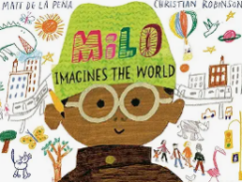  Milo Imagines the World by Matt de la Pena  (16 days)  Text Type: Narrative  Genre: Overcoming Difficulties Story  Topic: Similarities and Differences  Cross-curricular link: PSHE  How to Make a Bird Feeder  (16 days)  Text Type: Non-fiction  Genre: Instruction  Topic: Dr Doolittle/Be Kind to The Planet  Cross curricular links: Science/DT

