Year 3 – 2024 – 2025
Autumn 1 | Spring 1 | Summer 1
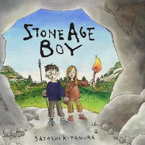  Stone Age Boy by Satoshi Kitamura  (15 days)  Text Type: Narrative  Genre – Story  Topic – Step Back in Time  Cross-Curricular – History  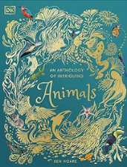  Skeletons and Muscles by Ben Hoare (18 days)  Text Type: Non-fiction  Genre – Non-Chronological Report  Topic – Skeletons & Muscles/Animals  Cross-Curricular – Science | 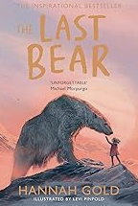  The Last Bear by Hannah Gold  (10 days)  Text Type: Narrative  Genre – Adventure  Topic – One planet/our world  Cross-Curricular - Geography/PSHE  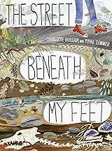  Street beneath my feet by Charlotte Guillain  (13 days)  Text Type: Non-fiction  Genre – Explanation  Topic - Rocks, Relics and Rumbles  Cross-curricular - Science  Additional Unit  The Colour Collector (based on The Sound  Collector by Roger McGough)  (16 days)  Genre – Poetry  Topic – The Importance of Colour in The World  Cross-curricular – Reading, Art & PSHE | 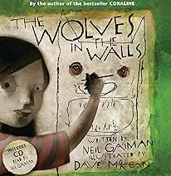  Wolves in the Wall by Neil Gaiman  (13 days)  Text Type: Narrative  Genre – Suspense  Topic – SSSSHHHH!!!/Who’s There?  Cross-Curricular – PSHE  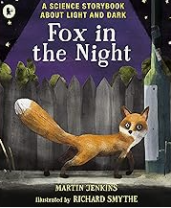  Light and dark (Based on Fox in the Night - Martin Jenkins)  (10 days)  Text Type: Non-fiction  Genre – Explanation  Topic - Light and Shadows  Cross-curricular - Science
Autumn 2 | Spring 2 | Summer 2
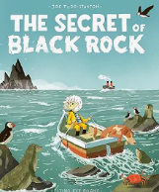  The Secret of Black Rock by Joe Todd-Stanton  (17 days)  Text Type: Narrative  Genre – Adventure  Topic – Adventure/Time Under the Sea  Cross-Curricular – Science/Geography  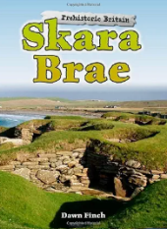  Skara Brae by Dawn Finch  (16 days)  Text Type: Non-fiction  Genre – Holiday Brochure  Topic – Stone Age/Step Back in Time  Cross-Curricular – History | 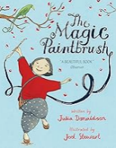  The Magic Paintbrush by Julia Donaldson  (10 days)  Text Type: Narrative  Genre – Traditional tale  Topic – Colour  Cross-Curricular - Art  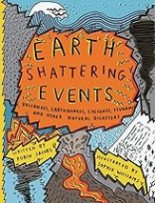  Earthquakes by Robin Jacobs  (15 days)  Text Type: Non-fiction  Genre – Non-chronological report  Topic - Rocks, Relics and Rumbles  Cross-curricular - Geography | 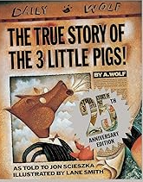  The True Story of the Three Little Pigs by Jon Scieszka.  (11 days)  Text Type: Narrative  Genre – Traditional tale with a twist  Topic – Once Upon A Tale/Points Of View  Cross-Curricular - Drama  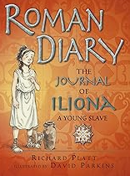  The journal of Ilona by Richard Platt  (11 days)  Text Type: Non-fiction  Genre – Diary  Topic – Emperors and Empires  Cross-curricular – History

