Year 4 – 2024 – 2025
Autumn 1 | Spring 1 | Summer 1
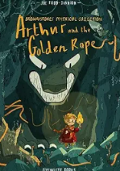  Arthur and the Golden Rope by Joe Todd-Stanton  (14 days)  Text Type: Narrative  Genre – Norse Myth  Topic – Viking Quest  Cross-Curricular – History  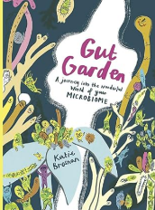  Digestion Explanation based on Gut Garden – A journey into the Wonderful World of your Microbiome by Katie Brosnan  (15 days)  Text Type: Non-fiction  Genre – Explanation  Topic – Food, Glorious Food  Cross-Curricular – Science | 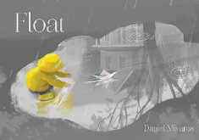  Float by Daniel Miyares  (18 days)  Text Type: Narrative  Genre – Story  Topic - Water, Water Everywhere/Put Your Wellies On  Cross-curricular – Geography  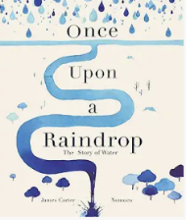  Once upon a Raindrop by James Carter  (19 days)  Text Type: Non-fiction  Genre – Script for factual tour  Topic – The Water Cycle/Water Water Everywhere  Cross-curricular – Geography/science | 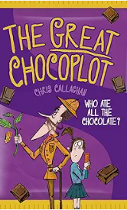  The Great Chocoplot by Chris Callaghan  (16 days)  Text Type: Narrative  Genre – Mystery  Topic – Aztecs/Easter  Cross-curricular - History  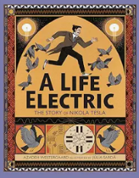  Nikola Tesla by Azadeh Westergaard  (16 days)  Text Type: Non-fiction  Genre – Biography  Topic – Save the Planet  Cross-curricular - Science
Autumn 2 | Spring 2 | Summer 2
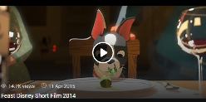  Feast by Disney (Film Clip)  (18 days)  Text Type: Narrative  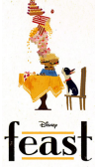  Genre - Story  Topic - Food glorious food/pets  Cross-curricular - DT (food & packaging)  Alternative to Plastic Straws - Stroodles  (15 days)  Text Type: Non-fiction  Genre - Persuasive advert  Topic - Eco-Warriors  Cross-curricular - Science/Geography | 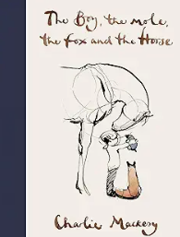  The Boy, The Mole, The Fox and The Horse by by Charlie Mackesy  (15 days)  Text Type: Narrative  Genre - Story of Friendship & Hope  Topic – Friendship & Hope  Cross-curricular - Art/Reading/PSHE/Science  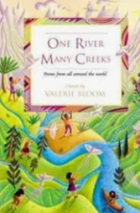  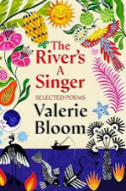  The River by Valerie Bloom  (15 days)  Text Type: Non-fiction  Genre- Poetry  Topic – Once Upon a Raindrop/Water Water  Everywhere  Cross-curricular – Geography/science | 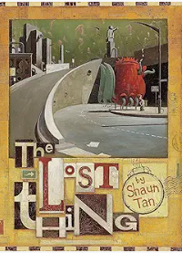  The Lost Thing by Shaun Tan  (19 days)  Text Type: Narrative  Genre – Fantasy  Topic – Lost & Found/Belonging  Cross-curricular - DT  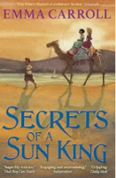  Secrets of a Sun King by Emma Carroll  (21 days)  Text Type: Non-fiction  Genre – Diary  Topic – Egyptians  Cross-curricular – History

