Year 5 – 2024 – 2025
Autumn 1 | Spring 1 | Summer 1
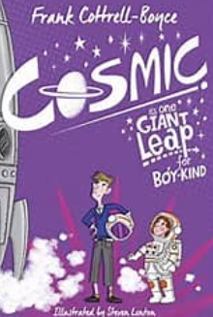  Cosmic by Frank Cottrell Boyce  (12 days)  Text Type: Narrative  Genre – Science Fiction  Topic – To Infinity and Beyond  Cross-Curricular – Science  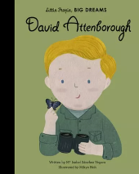  David Attenborough by Maria Isabel Sanchez Vegara  (19 days)  Text Type: Non-fiction  Genre – Biography  Topic – Save the Planet  Cross-Curricular – Science | 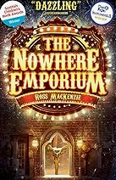  The Nowhere Emporium by Ross MacKenzie  (18 days)  Text Type – Narrative  Genre – Mystery  Topic – The Old Curiosity Shop  Cross-curricular – Drama  The Most Dangerous Animals in the World by Valerie Bloom  (14 days)  Text Type – Non-fiction  Genre - Poetry  Topic – Animals  Cross-curricular – Science | 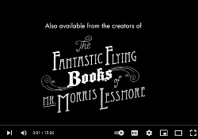  The Fantastic Flying Books of Mr Morris Lessmore by Moonbot Studios (film clip)  (15 days)  Text Type: Narrative  Genre – Fantasy  Topic – The Library of Life  Cross-curricular – Art  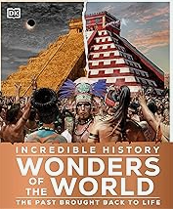  Ancient Greek Recount (Year 4 Unit)  (17 days)  Text Type: Non-fiction  Genre – Recount  Topic – Ancient Greek  Cross-curricular – History
Autumn 2 | Spring 2 | Summer 2
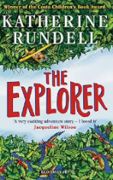  The Explorer by Katherine Rundell  (19 days)  Text Type: Narrative  Genre – Adventure  Topic – Under the Canopy  Cross-Curricular – Geography  Mars Transmission Journal  (20 days)  Text Type: Non-fiction  Genre – Journal  Topic – Calling Earth  Cross-Curricular – Science | 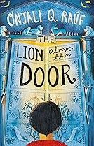  The Lion Above the Door by Onjali Q.Rauf  (14 days)  Text Type: Narrative  Genre – Story  Topic – Families  Cross-curricular – History  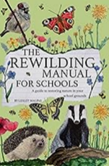  The Rewilding Manual for Schools  (18 days)  Text Type: Non-fiction  Genre – Explanatory Blog  Topic – Wild/Looking after the Planet  Cross-curricular – Geography | 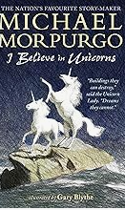  I Believe in Unicorns by Michael Morpurgo  (20 days)  Text Type: Narrative  Genre – Story  Topic – All Ablaze  Cross-curricular – History  Plastic Pollution  (23 days)  Text Type: Non-fiction  Genre – Speech  Topic – What a load of Rubbish  Cross-curricular – Geography/Science

