Year 6 – 2024 – 2025
Autumn 1 | Spring 1 | Summer 1
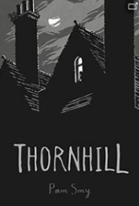  Thornhill  (17 days)  Text Type: Narrative  Genre - Ghost Story  Topic – Haunted  Cross-Curricular – Drama  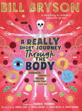  Factual Tour of the Circulatory System  (17 days)  Text Type: Non-fiction  Genre – Tour Guide Script  Topic – Our Bodies  Cross-Curricular – Science | 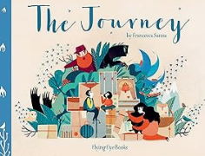  The Journey by Francesca Sanna  (18 days)  Text Type: Narrative  Genre – Story  Topic – New Start  Cross-curricular – PSHE  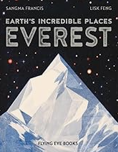  Everest by Sangma Francis and Lisk Feng  (16 days)  Text Type: Non-fiction  Genre – Non-Chronological Report  Topic – Climbing High/Explorers  Cross-curricular – Geography | 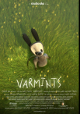  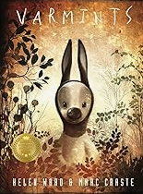  Varmints by Marc Craste  (film clip & book)  (18 days)  Text Type: Narrative  Genre – Story  Topic – Creatures  Cross-curricular – Science/Geography  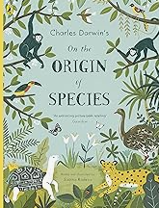  The Origin of Species by Sabina Radeva N  (19 days)  Text type: Non-fiction  Genre – non-chronological report  Topic – Adaption  Cross-curricular – Science
Autumn 2 | Spring 2 | Summer 2
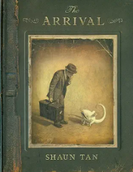  The Arrival by Shaun Tan  (16 days)  Text Type: Narrative  Genre - Picture Book  Topic – Journey  Cross-Curricular – PSHE  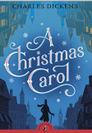  Letter to Mr Scrooge  (22 days)  Text Type: Non-fiction  Genre – Persuasive Letter  Topic – Bah Humbug  Cross-Curricular – History | 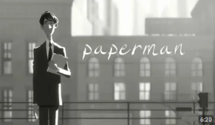  Paperman by Disney  (film clip)  (18 days)  Text Type: Narrative  Genre – Romance  Topic – Together  Cross-curricular – DT  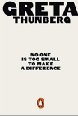  Greta by Greta Thunberg  (18 days)  Text type: Non-fiction  Genre – Speech  Topic – Planet Rescue  Cross-curricular – Science/Geography | 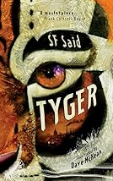  Tyger by SF Said  (17 days)  Text Type: Narrative  Genre - Adventure in Dystopian World  Topic – Animals  Cross-curricular – Geography  Post Card from Prison  (10 days)  Text Type: Non-fiction  Genre – Postcard  Topic – Locked up  Cross-curricular – Drama  PTO  Additional Unit  10 Things in a Soldier's Pocket by Ian MacMilan  (13 days)  Text Type: Non-fiction  Genre – List Poetry  Topic – War  Cross-curricular – History

